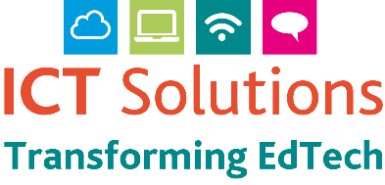
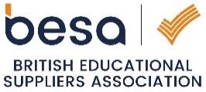
COVID dramatically disrupted our way of life for the past two years, and its impact became the primary focus for all education establishments as they had to adapt to new ways of teaching. This brought fast and significant changes to the way technology was used within the education sector, where the need for seamless transition between learning establishments and home became critical.
ICT SOLUTIONS

CONTACT US:

ict@norfolk.gov.uk

01603 475603

www.ict.norfolk.gov.uk

It’s time to reflect and move forward with your ICT

Coming out of this period, a time of reflection on how this has impacted your current ICT practices and dependencies on your broadband network and equipment is paramount. The need to plan has become more of a priority and to evaluate how new technologies can improve changes which have already had to be made and enable establishments to be ready for any future challenges.

Our Solution
A new 4 year Refresh and Enhancement Programme which can act as a one stop shop to manage all your ICT Requirements.

- Broadband  - Network & Wireless  - Telephony  - Server migration to cloud services  - Cloud Services  - Licencing  - Curriculum Devices | - Staff Devices  - Audio Visual  - CPD ICT Training  - Microsoft/Google/Apple  - STEM/VR/Coding  - ICT Support  - Cyber Security
We recognise that with the constraints on budgets, not all of these items can be dealt with at once and being able to plan your budget for such items over a 4 year period is beneficial for managing finances, so that a full roll-out of services can be achieved.

What makes this Programme unique?
At the end of the Programme, equipment purchased is your property with no extensions of contract or additional costs necessary, unlike leasing, where you do not own the equipment at the end of the contract. Lease agreements can be very complex and have specific clauses which could incur further un-planned costs.

The ICT Solutions Refresh Enhancement Programme is transparent and straightforward. It does not involve complicated agreements and is simply a way to commit money into a central pot which you can draw from in a managed/planned way in co-ordination with ourselves. It provides flexibility in that the money does not have to be spent all at once and elements of work can be delivered in stages to ensure that you and your staff are not overwhelmed.
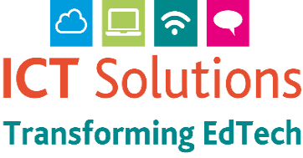
How the Programme is managed:

It’s time to reflect and move forward with your ICT

ICT SOLUTIONS

CONTACT US:

ict@norfolk.gov.uk

01603 475603

www.ict.norfolk.gov.uk
- Your own dedicated customer area which allows you to review budget status, programme and catalogue of equipment and services provided.
- Dedicated Project Lead and support staff.
- Financial Management assisted by NCC Finance.
- Regular communication with Project Lead and Technical Staff.
- On-site and Virtual Meetings.
- Pre and Post Work training with Management and Staff Teams.
- Quality Assurance of each element of work.
- All Health and Safety aspects are considered by our Project Team and Suppliers as directed by NCC Health & Safety processes.
- Supplier Management via NCC/Government Frameworks to ensure correct procurement procedures are followed.

ICT Solutions Cloud Services
ICT Solutions offer cloud services from Google and Microsoft. Moving to the cloud will allow your establishment to work and collaborate more flexibly and provide teachers/students with all of the tools required to enable and enhance remote learning with Google Workspace and Microsoft 365. You can also manage devices via the cloud for easy enrolment and management of apps and settings, meaning less reliance on on-premises servers which can bring potential cost savings.

Other Benefits
- All recommended products are put through an evaluation process by our Engineers
- Access to educational discounted products via our framework supply partners
- Peace of mind for a safe investment
- We are a Microsoft and Google certified partner and trainers
- Free recycling and WEEE certification
- 50% off half day guided session with our VR or Sphero Loan Equipment

To Register Interest, please click here

We can offer a solution to all education establishments i.e., schools, academies, partnerships and trusts, independent schools and colleges, either as a single entity or via a trust-wide approach.

