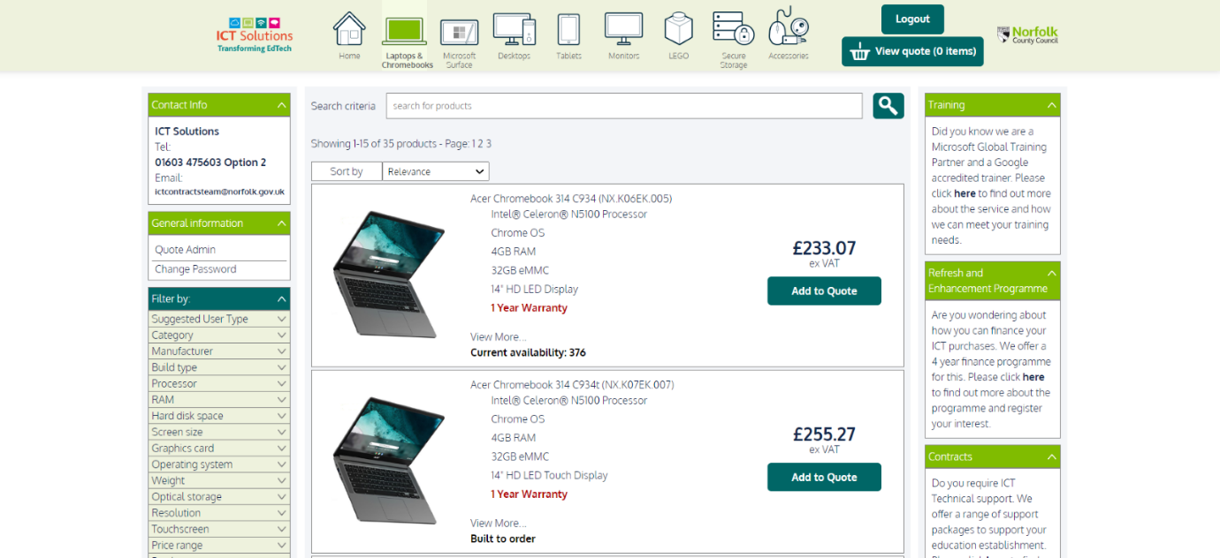

**The Norfolk County Council/ICT Solutions Procurement Portal pricing is solely for use by Education establishments (Schools, Academies, Colleges, Nurseries etc.) and must not be shared with third party suppliers/providers.**